Peter Crowley @ Chemistry, NUI Galway, IRELAND
After graduating from University College Dublin with first class honours in chemistry Peter joined the laboratory of Prof. G. W. Canters at Leiden University, The Netherlands. Working with his advisor Prof. M. Ubbink, he used NMR spectroscopy to study transient protein interactions involved in electron transport. This research was summarized in an invited paper in Accounts of Chemical Research.
From the Netherlands, Peter headed south for sunnier climes. With a Marie Curie Postdoctoral fellowship he joined the laboratory of Prof. M. A. Carrondo at Universidade Nova de Lisboa, Portugal. During this time he further developed his interest in molecular recognition. In particular, he demonstrated the importance of cation-pi interactions in protein interfaces (Crowley & Golovin, Proteins 2005).
In 2006, Peter returned to Ireland, working as a lecturer in Biochemistry at UCD, and since 2008 as a lecturer in Chemistry at NUI Galway. In 2014 he was promoted to Senior lecturer. Current interests include protein self assembly and protein interactions under physiological conditions. The Crowley laboratory gratefully acknowledges funding from NUI Galway and Science Foundation Ireland.

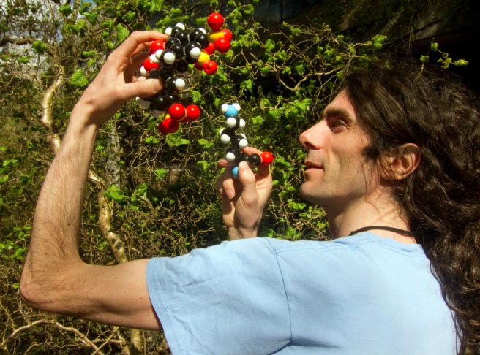 | 