Oscar Francesconi
Post-doc in Supramolecular Chemistry at the University of Firenze
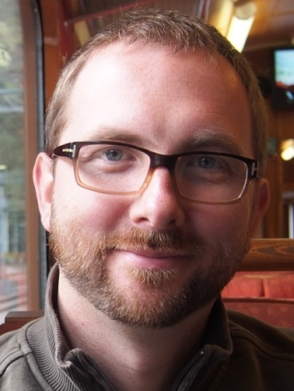
Address: Department of Chemistry “Ugo Schiff”, University of Florence,
Via della Lastruccia, 13, I-50019 Sesto Fiorentino (FI)
E-mail: oscar.francesconi@unifi.it
Education:
Oscar Francesconi graduated in Pharmaceutical Chemistry and Technology at the University of Firenze, Italy, in 2005, where he received his PhD in 2010 defending a thesis on “Synthetic Receptors for the Molecular Recognition of Carbohydrates”. He is currently a Postdoctoral Research Assistant in the group of Prof. Cristina Nativi and Dr. Stefano Roelens at the Department of Chemistry of the University of Firenze
Professional experience:
The research interests of Oscar Francesconi are in supramolecular chemistry and physical-organic chemistry, with particular reference to the molecular recognition of carbohydrates, focusing on the design, synthesis, and evaluation of the molecular recognition properties of new artificial receptors for saccharides of biological interest. He is author of 23 publications on international peer-reviewed journals and 2 book chapters. From 2013 to 2015 he has been a member of the directory board of the Young Group of the Italian Chemical Society. In 2016 he was awarded with the Research Prize “Organic Chemistry for the Life Sciences” by the Organic Chemistry Division of the Italian Chemical Society.

