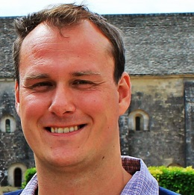
Curriculum Vitae – Matija Gredičak
Personal Data
- Name and Surname: Matija Gredičak
- Date of Birth: 21/01/1981
- Place of Birth: Zagreb, Croatia
- Email: matija.gredicak@irb.hr
- Telephone: +385 1 4560 998

Research Experience

2014 – Rudjer Boskovic Institute, Zagreb, Croatia
- research associate
2012 – 2014 Oxford University, Oxford, United Kingdom
- postdoctoral fellow; asymmetric catalysis
- supervisor: Dr. Martin D. Smith
2011 European Institute for Chemistry and Biochemistry, Bordeaux, France
- postdoctoral fellow; foldamer synthesis
- supervisor: Dr. Ivan Huc
2005 – 2010 Rudjer Boskovic Institute, Zagreb, Croatia
- Ph.D. in synthetic organic chemistry
"Synthesis and reactivity of amino acid-derived enediynes"
- supervisor: Dr. Ivanka Jerić

Grants

2015 – 2017 "Sustainable methodologies enabling asymmetric synthesis of priviledged cores of natural products"
- with Prof. Shu-Li You, Shanghai Institute of Organic Chemistry
2015 – 2016 "Sustainable methodologies for drug synthesis: Inspirations from Nature"
- young researcher Croatian Science Foundation-Abbvie grant

Awards

2015 "Vladimir Prelog" Prize – Croatia's best young organic chemist researcher

Recent Publications
- J. Suć, I. Dokli, M. Gredičak "Chiral Brønsted Acid-Catalysed Enantioselective Synthesis of Isoindolinone-Derived N(acyl),S-Acetals" Chem. Commun. 2016 (52) 2071–2074.

- I. Dokli, M. Gredičak "Mechanochemical Ritter Reaction: A Rapid Approach to Functionalized Amides at Room Temperature" Eur. J. Org. Chem. 2015 (12) 2727–2732.

